Red, white and blue circular logo that says Sac County Votes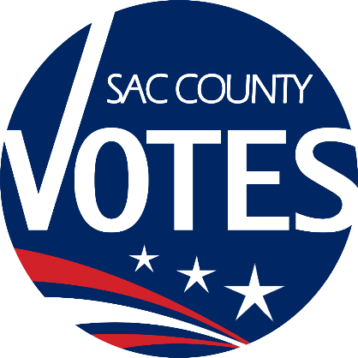

**CO-CHAIRS**

JANNA FIORI

SAM WINTERS

CJ MORRISON

COLIN MCINNIS

**Sacramento County**

**Voter Registration & Elections**

Voting Accessibility Advisory Committee

**January 30, 2025 Meeting Agenda**

**10:00 AM**

**Location: Microsoft Teams**

**Microsoft Teams** [**Need help?**](https://aka.ms/JoinTeamsMeeting?omkt=en-US)

[**Join the meeting now**](https://teams.microsoft.com/l/meetup-join/19%3ameeting_YmM5MDhkYzUtOTc5OS00ZGEwLTk4MGEtY2FjYTFmNjBmNmQ4%40thread.v2/0?context=%7b%22Tid%22%3a%222b077431-a3b0-4b1c-bb77-f66a1132daa2%22%2c%22Oid%22%3a%22468438cd-24cb-42fc-851b-194af32e476b%22%7d)

**Meeting ID: 292 269 782 788**

**Passcode: 54sZ7oo6**

**Dial in by phone**

[**+1 916-245-8966,,178045887#**](tel:+19162458966,,178045887) **United States, Sacramento**

[**Find a local number**](https://dialin.teams.microsoft.com/e6ecf38a-c5f2-4b16-8b9b-b2e22c716ef8?id=178045887)

**Phone conference ID: 178 045 887#**

**Agenda Items:**

1. Welcome and introductions
2. Updates from State VAAC
3. VAAC-related General Election debrief
4. VAAC recruitment
5. Open Discussion
6. The next VAAC meeting will be on July 31 at 10 a.m.
7. Adjourn

Requests for documents in accessible formats, interpreting services, language assistance, assistive listening devices, or other accommodations should be made by calling the County Voter Registration and Elections Department at (916) 875-6512 or by emailing your request to [VAACInfo@saccounty.gov](mailto:LAACInfo@saccounty.gov), no later than 5 days prior to the meeting.