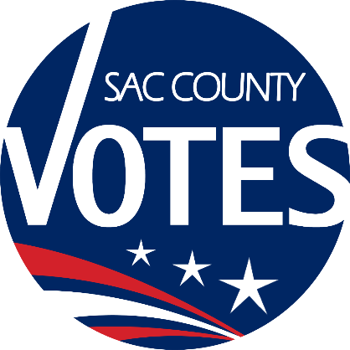

CO-CHAIRS
JANNA FIORI
SAM WINTERS
CJ MORRISON
COLIN MCINNIS

Sacramento County
Voter Registration & Elections
Voting Accessibility Advisory Committee

January 30, 2025 Meeting Agenda
10:00 AM

Location: Microsoft Teams
Microsoft Teams Need help?
Join the meeting now
Meeting ID: 292 269 782 788
Passcode: 54sZ7oo6

Dial in by phone
+1 916-245-8966,,178045887# United States, Sacramento
Find a local number
Phone conference ID: 178 045 887#

Agenda Items:
- Welcome and introductions
- Updates from State VAAC
- VAAC-related General Election debrief

- VAAC recruitment
- Open Discussion
- The next VAAC meeting will be on July 31 at 10 a.m.
- Adjourn
Requests for documents in accessible formats, interpreting services, language assistance, assistive listening devices, or other accommodations should be made by calling the County Voter Registration and Elections Department at (916) 875-6512 or by emailing your request to VAACInfo@saccounty.gov, no later than 5 days prior to the meeting.

