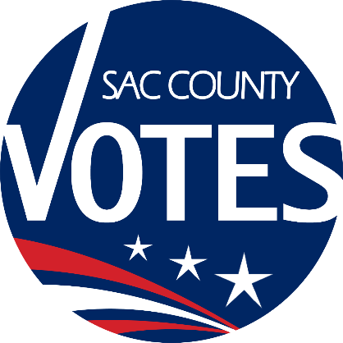

CO-CHAIRS
KAREN STARTUP
EMILY ELLIOTT
MIKE VANDERPOOL
JANNA FIORI

Sacramento County
Voter Registration & Elections
Voting Accessibility Advisory Committee

July 24, 2025 Meeting Agenda
10:00 AM

Location: Microsoft Teams Need help?
Join the meeting now
Meeting ID: 240 229 056 610
Passcode: T9px9Jr3
Dial in by phone
+1 916-245-8966,,490710765#
United States, Sacramento
Find a local number
Phone conference ID: 490 710 765#
Agenda Items:
- Welcome and introductions
- Updates from State VAAC
- Open Discussion
- The next VAAC meeting will be on January 22, 2026 at 10 a.m.
- Adjourn
Requests for documents in accessible formats, interpreting services, language assistance, assistive listening devices, or other accommodations should be made by calling the County Voter Registration and Elections Department at (916) 875-6512 or by emailing your request to VAACInfo@saccounty.gov, no later than 5 days prior to the meeting.

