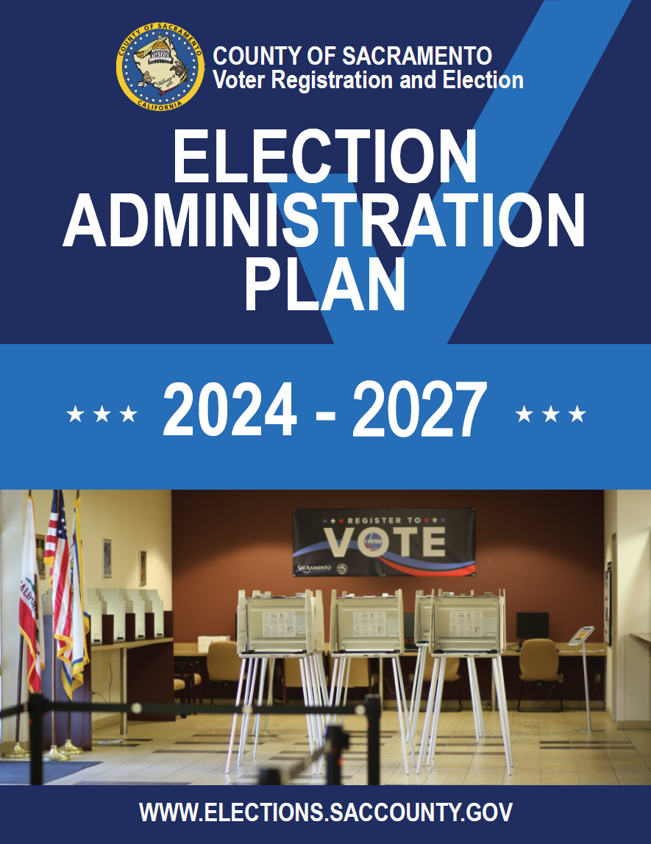

Table of Contents
Part I
Overview of the Election Administration Plan
Vote by Mail
Vote Center and Ballot Drop Box Locations
Vote Center Formula and Considerations
Ballot Drop Box Location Formula and Considerations
Services for Voters with Disabilities
Voting Accessibility Advisory Committee (VAAC)
Services for Voters with Disabilities
Remote Accessible Vote by Mail
Toll-free Voter Assistance Hotline
Language Assistance Services
Language Accessibility Advisory Committee (LAAC)
Language Assistance
Toll-free Voter Assistance Hotline
Addressing Gaps in Participation
Part II
Overview of Election Security Action Plan
Security and Contingency Plan to Ensure Prevention of Disruption
Vote Center Continuity of Operations
Methods and Standards
Part III
Overview of Voter Education and Outreach Plan
Background
Summary of Goals
Voter Engagement
Voter Education
General Media Plan
Direct Voter Contacts
Public Service Announcements
Website
Projected Budget for Voter Education and Outreach
Part IV
Appendices
- Community Events and Partners
- Direct Voter Contact
- Media Partners
- Budget
- Vote Center Layout
- Communication Action Plan
- Vote Center Locations and Hours
- Ballot Drop Box Locations and Hours
- Location Maps
- Correctional Facilities

PART I:

Overview of the Election Administration Plan
§4005(a)(10)(A)

Background
The California Voter’s Choice Act (VCA) requires a County to submit an Election Administration Plan (EAP) to the public that conveys how the County of Sacramento Voter Registration & Elections Department (VRE) will administer elections under the VCA.
The County of Sacramento was the largest of five pilot counties to adopt the VCA for the 2018 Statewide Gubernatorial Elections. Both elections experienced a record high voter turnout for a midterm election where just over 94% of all voters used the Vote by Mail (VBM) ballot mailed to them instead of voting in-person. VRE is working on making continuous improvements to process the large number of returned VBM ballots and to the in-person voting experience. This trend has continued throughout the last few elections administered in the County of Sacramento.

Election | Voted Vote by Mail  Ballot | Voted in-person at Vote Center
June 2018 | 293,298 (94%) | 18,180 (6%)
November 2018 | 485,686 (93%) | 37,313 (7%)
March 2020 | 377,328 (94%) | 32,439 (6%)
November 2020 | 683,428 (94%) | 46,084 (6%)
June 2022 | 326,172 (97%) | 10,543 (3%)
November 2022 | 459,920 (95%) | 24,830 (5%)

This plan will outline the events that take place to administer an election under the VCA.

Pre-Election Review
Various methods of data collection were utilized during the inaugural implementation of the VCA in 2018 and for subsequent elections administered in the County of Sacramento to help VRE improve the voting experience for future elections. These methods will also be used during each election cycle.

Call Logs
VRE uses call log software to track all voter calls and incidents beginning 29 days before Election Day. The review of these call logs helped VRE identify frequently asked questions from voters, concerns from voters regarding their voting experience, usability of mailed voting materials, and how the equipment performed under this new model. These call logs will be essential in our preparation for upcoming elections and the anticipated higher turnout.

Voter Experience Survey
An online survey was created for voters to let us know about their experiences at Vote Centers. The survey consisted of 13 questions including: assistance needed at a Vote Center, how voters heard about the changes under the VCA, wait time, barriers to voting, and overall satisfaction with the Vote Center and staff. This survey was used by the Precinct Operations team to procure Vote Centers with more space for future elections, improve Vote Center Staff training, and pinpoint specific issues relating to each Vote Center location, like parking concerns. This also assisted the Outreach team in preparing election messaging, which will now include “Vote Early & Avoid the Lines”. Overall, of 182 completed surveys from November of 2022, 89% were satisfied or very satisfied with their voting experience.

Inspector Debrief
VRE held Inspector (Vote Center Supervisor) debriefing sessions following both elections to improve training and address voter concerns. These debriefings were held virtually through Zoom.

Vote by Mail
§4005(a)(8)(A)
Every active, registered voter in the County of Sacramento will be mailed a VBM packet in the mail beginning 29 days before each Election.
VRE utilizes a state certified vendor who can handle the VBM ballot printing and mailing capacity. The office has maintained a long-term, strong partnership with local United States Postal Service (USPS) staff to ensure timely delivery and return of VBM ballots.
The VBM ballot packet is sent to voters in a white envelope with the Official USPS Election Mail logo and contains:
- The Voter’s Official Ballot. The Official Ballot contains all contests the voter is eligible for based on where they reside.
- Pink Return Envelope. Also known as the “identification envelope”, is voter-specific and used by the voter to return their voted Official Ballot to VRE. Every pink return envelope has two punched holes, used as a signature guide. It is important for the voter to sign and date between the two punched holes. If the voter places their ballot inside the ballot envelope and feel the two punched holes have compromised the integrity of their privacy, they can flip the ballot around or fold it in any manner that fits inside the envelope.​
- Ballot Drop Box Locations. This insert consists of a map and a list of all Ballot Drop Boxes in the county with their addresses and days/hours of operation. Days and hours may vary by location, please refer to the website for the most up-to-date information.
- Vote by Mail Instructions. This insert promotes voting by mail as safe and secure. It reminds voters to sign their envelope and vote early, lets them know what to do if they make a mistake in marking their ballot, and encourages them to sign up for Where’s My Ballot? If they wish to track the status of their ballot.
- An "I Voted" Sticker. This insert contains an “I Voted’ sticker, a suggestion to vote early, and reminders for how to vote and return the Official Ballot.
Election materials, like Official Ballots, are not forwarded by the USPS (Election Code §3008(b)). Undeliverable election materials are returned to VRE by the USPS and is utilized by VRE to conduct regular voter file maintenance tasks.
If a voter does not receive their VBM ballot packet they may request a replacement VBM ballot packet by:
- calling the office at (800) 762-8019,
- emailing their request to vbm@saccounty.gov,
- faxing their request to (916) 854-9796,
- visiting the VRE main office or any Vote Center when open, or
- accessing the Remote Accessible Vote by Mail (RAVBM) system by using the Voter Look Up Tool.

A voter’s VBM ballot packet may also be picked up by an authorized representative, such as a friend or relative. The voter is required to complete an Authorization For Mail Ballot Pick-Up form, available found on the VRE website or at any Vote Center.
VBM ballots may be returned postage-paid through the mail, or at any Ballot Drop Box, or Vote Center location. Before returning a VBM ballot, it is important for the voter to sign and date the pink return envelope between the two punched holes. If the voter places their ballot inside the ballot envelope and feel the two punched holes have compromised the integrity of their privacy, they can flip the ballot around or fold it in any manner that fits inside the envelope.​
If the voter cannot sign their name and have no other legal mark that they can use in place of signing their name, the voter must make an “X” or other simple mark between the two punched holes. The voter must have another person write the voter’s name near the voter’s mark and sign as a witness. The person witnessing the voter’s mark must be at least 18 years old.
See section regarding Signing Election Documents on page 14 of this document for additional information.
If the pink return envelope is not signed, or if the signature does not match what is on the voter file, VRE will contact the voter to verify their information.

Life of a Ballot

The Official Ballot is Printed.

Ballots are printed and inserted into VBM ballot packets by our print contractor that has met certification requirements by the Secretary of State to produce ballots for the State of California.

The Official Ballot is Mailed.

Ballots are automatically mailed to all “active” voters through the United States Postal Service (USPS) beginning 29 days before Election Day.

The Official Ballot is Returned.

Voted VBM ballots are postage-paid and returned through the USPS, Ballot Drop Boxes, or in-person at a Vote Center.

The Official Ballot is Received.

Returned VBM ballots are passed through an industrial mail sorter that date and timestamps the pink return envelope, while capturing the signature image.

The Signature is Compared.

The signature image from the pink return envelope is compared to the voter’s signature on file.

The Pink Return Envelope is Opened.

VBM ballots are removed from pink return envelopes with a high speed envelope opener/extractor. One the ballot is removed from the pink return envelope, it is completely anonymous – there is nothing on the Official Ballot to link it to the voter.

The Official Ballot is Examined.

Any damaged ballot that cannot be read by a scanner are sent to a Duplication Team. The Official Ballot will be examined to determine voter intent and recreated by marking a balnk ballot.

The Official Ballot is Scanned.
All ballots in the County of Sacramento are centrally counted at the VRE office located at 7000 65th Street, Suite A, Sacramento, CA 95823.

VRE will run the Official Ballots through ballot scanners that read the ballot marks to indicate the voter’s choices, then pass the results to a tabulation computer.

VRE Reviews Voter Intent.

If a voter has over- or under-voted for a contest, or if voter intent is unclear, the Official Ballot is reviewed on screen by a team of adjudicators.

VRE Reports Election Results.

The results from each ballot scanner is sent to the ballot tabulation computer. Election Results are saved to an external drive, printed, then uploaded to our website.

VRE Certifies the Election.

The work doesn’t end when the polls close. After Election Day, VRE continues to verify ballots received timely, conducts a manual audit and official canvass to ensure every eligible vote is counted before certifying the results.

Tracking VBM Ballots
The California Secretary of State (SOS) has a ballot tracking system called Where’s My Ballot?, operated through BallotTrax. Voters can subscribe to Where’s My Ballot? for additional transparency and security as their VBM ballot moves through the USPS mail stream back to VRE. VBM ballot envelopes are tracked using an Intelligent Mail Barcode (IMB) which the USPS uses to track when ballots are mailed and returned to VRE.

Vote Center and Ballot Drop Box Locations
§4005(a)(10)(B)
The VCA establishes detailed criteria and formulas for the placement and locations of Vote Centers and Ballot Drop Box locations. Vote Centers and Ballot Drop Box locations will be decided based on specific considerations and requirements described below:
- Proximity to public transportation
- Proximity to communities with historically low Vote by Mail usage
- Proximity to population centers
- Proximity to language minority communities
- Proximity to voters with disabilities
- Proximity to communities with low rates of household vehicle ownership
- Proximity to low-income communities
- Proximity to communities of eligible voters who are not registered to vote and may need access to same day voter registration
- Proximity to geographically isolated populations, including Native American reservations
- Proximity to college campus or university
- Access to accessible and free parking
- The distance and time a voter must travel by car or public transportation
- Traffic patterns near vote centers and ballot drop-off locations
- The need for alternate methods for voters with disabilities to cast a ballot
- The need for mobile vote centers in addition to the number of Vote Centers established pursuant to this section
Prior to 2018, VRE performed an analysis of the VCA criteria and created a VCA Story Map. VRE will use this same methodology for future Vote Center and Ballot Drop Box locations. A complete list may be found in Appendix H.

Vote Center Formula and Considerations
§4005(a)(10)(l)(vi)(l)
The VCA requires that the number of Vote Centers be based on voter registration totals for the County 88 days before the Election. To ensure there is an adequate selection of Vote Centers to choose from, surveys of potential locations began in early-2023. Facility confirmations begin a year in advance for libraries and community centers and continue until two-months before Election Day.
VRE is required to provide one 11-day Vote Center for every 50,000 registered voters and one 4-day Vote Center for every 10,000 registered voters. Based on projections for increased voter registration totals, VRE is looking to confirm the following for the March and November 2024 elections:
- Eighteen 11-day Vote Centers
- Seventy-two 4-day Vote Centers
As of April 2023, the County of Sacramento has 870,687 registered voters. VRE projects the number will grow to 900,000 registered voters ahead of the 2024 election cycle.

Vote Center Minimum Requirements and Site Selection
Prior to 2018, VRE performed an analysis of the VCA criteria and created a VCA Story Map. This data will be used to determine Vote Center locations.
Vote Center locations will be selected based on requirements set forth in statute, the accessibility to voters with disabilities and language needs, location availability, and public feedback.
A current list may be found in Appendix G.

Vote Center Survey Assessment
In addition to considering required criteria, a Vote Center accessibility assessment is used to determine if there are existing barriers that may impact a voter’s ability to vote privately and independently. VRE also evaluates elements such as path of travel, size of the voting area, the presence of adequate lighting, the geographic area of the proposed site, and electrical capacity.

Vote Center Facility Recruitment Process
Locations unable to accommodate vote center operations, such as private residences and locations under 1,000 square feet, were contacted to inform them of the transition to a new voting model and thanked them for their past service. The remaining facilities were moved forward to the next level of review in the recruitment process.

Vote Center Facility Research
Based on the previous facility recruitment process, VRE maintains a list of over 335 potential voting locations and regularly reviews the locations for accessibility compliance.
As additional Vote Centers are required, both private and public facilities are contacted to determine availability and potential costs. Once facilities confirm, site surveys are conducted to ensure minimum requirements and accessibility compliance are met.
Consistent with previously used Polling Place research, additional public properties and facilities within the county are constantly evaluated and added to a master list for further research. Suitable facilities, that have not served as Polling Places, have been contacted for Vote Center site surveys.

List of Potential Vote Centers with Days and Hours of Operation
§4005(a)(10)(l)(vi)(III), §4005(a)(10)(l)(vi)(VI)
A list of proposed Vote Center locations may be found in Appendix G. As Vote Center locations are confirmed the appendix will be updated.
To view the complete and updated list of Vote Center locations for the upcoming election, visit the VRE website at elections.saccounty.gov beginning 29 days before Election Day.
Map of Suggested Areas for Vote Centers
See Appendix I.

Mobile Vote Centers
§4005(a)(10)(B)(xiv)
VRE continues to evaluate the opportunity to bring Mobile Vote Centers to geographically isolated areas of the county. VRE plans to pursue this option for future election cycles to ensure access to in-person voting opportunities for all voters of the County of Sacramento.
VRE will ensure all future Mobile Vote Centers deployments are methodically planned, secure, and well-equipped to support voters with language and accessibility needs.

Vote Center Layout
§4005(a)(10)(l)(vi)(XI)
Any eligible resident of the County of Sacramento may visit a Vote Center beginning 10 days before the election. Vote Centers offer voters enhanced services and benefits that are secure and convenient.
All Vote Centers will be equipped with a minimum of:
- Two check-in laptops to securely verify the status and eligibility of the voter
- An accessible voting booth for a chair or a wheelchair
- A magnifying glass, signature guides, and pen grips
- Three accessible ballot marking devices
- A ballot printer
At Vote Centers, a voter will be able to:
- Vote in-person
- Pick up a replacement ballot
- Drop off a voted VBM ballot
- Use the accessible ballot marking device to independently and privately mark their ballot
- Receive language assistance
- Register to vote for the first time, or update their registration using Conditional Voter Registration
All locations are provided with layout guidelines to ensure voting booths and accessible ballot marking devices are placed in a manner that allows a voter to mark their ballot privately. Layouts are based on survey data, are sensitive to the accessibility needs of voters and are adjusted to accommodate the varying voting areas of each location.
A sample layout may be found in Appendix E.

Number of Vote Center Employees and Training
§4005(a)(10)(l)(vi)(IX)
Prior to every election cycle, VRE will train over 1,000 Vote Center staff to work at Vote Center locations throughout the County of Sacramento. The public is allowed to attend some portions of training but is not permitted to attend the hands-on portions due to proprietary software, voter privacy, and security concerns.
Vote Center Type | # Sites | Staffing Type | # Days | Full-day Shifts | Projected Staff
11-Day | 18 | 6-person staff | 11 Days | 18 sites x 6 staff | 108
4-Day | 72 | 12-person staff | 4 Days | 90 sites x 12 staff | 1,080
Total Projected Need | 90 |  |  |  | 1,188

Training of Vote Center Employees
All staff, including those working at Vote Centers and those providing technical and compliance support, attend training modules related to the operation of voting equipment, setting up a Vote Center, assisting and processing voters, securing sensitive equipment, and the proper procedures to follow in case of an emergency.

Ballot Drop Box Location Formula and Considerations
§4005(a)(10)(l)(vi)(II)
The VCA requires that the number of Ballot Drop Boxes be based on voter registration totals for the County 88 days before the Election. To ensure there is an adequate selection of Ballot Drop boxes to choose from, surveys of potential locations began in early 2023. Facility confirmations begin a year in advance for libraries and community centers and continue until two-months before the scheduled Election Day.
VRE is required to provide one Ballot Drop Box location for every 15,000 registered voters. Based on projections for increase in voter registration totals, VRE is looking to confirm the following for the March and November 2024 elections:
- 60 Ballot Drop Boxes (1 for every 15,000 registered voters)
As of April 2023, the County of Sacramento has 870,687 registered voters. VRE projects the number will grow to 900,000 registered voters ahead of the 2024 election cycle.

Ballot Drop Box Minimum Requirements
§4005(a)(10)(l)(vi)(VII)
In addition to VCA minimum requirements, the California SOS provides regulations to enforce accessibility and language requirements. VRE’s Ballot Drop Boxes are designed to meet accessibility, design, and public notification requirements.
Ballot Drop Box locations, whether indoors or outdoors, are determined based on the requirements set forth in the VCA, accessibility to voters with disabilities and language needs, location availability, and public feedback.

Ballot Drop Box Survey Assessment
In addition to considering required criteria, a Ballot Drop Box accessibility assessment is used to determine if there are existing barriers that may impact a voter’s ability to independently return their VBM ballot. VRE also evaluates other elements such as path of travel, the presence of adequate lighting, and the geographic area of the proposed site.

List of Potential Ballot Drop Boxes with Days and Hours of Operation
§4005(a)(10)(l)(vi)(IV), §4005(a)(10)(l)(vi)(VII)
A list of proposed Ballot Drop Box locations may be found in Appendix H. As Ballot Drop Box locations are confirmed the appendix will be updated.
To view the complete and updated list of Ballot Drop Box locations for the upcoming election, visit the VRE website at beginning 29 days before Election Day.

Map of Suggested Areas for Ballot Drop Box Locations
See Appendix I.

Services for Voters with Disabilities
§4005(a)(10)(l)(vi)(X)
VRE is committed to working with voters with disabilities to increase accessibility in the democratic process. The VRE website provides general information about these efforts and the resources available to voters with disabilities, including the Remote Accessible Vote by Mail (RAVBM) system, disability services available at Vote Centers, availability of election materials in alternate formats, and the Voting accessibility Advisory Committee (VAAC). A full listing of accessible voting options and assistance is located on the VRE website.

Voting Accessibility Advisory Committee
§4005(a)(9)(B)
VRE established the VAAC in 2017 as a citizen advisory committee to make recommendations for improving access to voting while working to identify and eliminate barriers. The VAAC is designed to advise and assist in ensuring all voters in the County of Sacramento can vote independently and privately. VRE will work with VAAC members to provide information and alternative voting options for voters with disabilities.
VAAC goals and agenda are located on the VAAC webpage.

Updated Accessibility Survey
§4005(a)(4)(C)
To comply with accessibility requirements, the Secretary of State Accessibility Checklist was reviewed, and additional requirements were added to VRE’s Accessibility Survey. The updated version focuses on a more in-depth examination of paths of travel from public transportation, seeking sites with a maximum number of accessible parking spaces, and additional questions to differentiate between types of curb ramps.
The past survey was also reviewed to ensure that all questions on the current survey follow the Secretary of State Accessibility Checklist and the requirements in the VCA. The format of the Vote Center Survey was updated from previous paper versions and outdated electronic versions to an application-based program that can be used on a mobile electronic device.

Services for Voters with Disabilities are included in the County Voter Information Guide (CVIG) and Vote By Mail Instructions
§4005(a)(8)(B)(i)(IV)
Voters with disabilities have several accessible voting options. VRE prepares a CVIG for each election which contains information on the VBM process as well as instructions for using the RAVBM system. The CVIG is available in large-print, PDF, and a screen reader accessible option using the Voter Look-Up Tool. Ballot measures are available in audio format on our website beginning 29 days before Election Day. Accessible voting options can be requested by emailing voter-outreach@saccounty.gov or calling VRE at (916) 875- 6451.
Ballot measures on audio are also available at the following locations:
- Braille & Talking Book Library, 900 N Street #100, Sacramento, CA 95814
- Folsom Library, 411 Stafford Street, Folsom, CA 95630
- Sacramento Central Library, 828 I Street, Sacramento, CA 95814
- Sacramento Society for the Blind, 1238 S Street, Sacramento CA 95811
- Sacramento County Voter Registration & Elections, 7000 65th Street, Suite A, Sacramento, CA 95823
A full list of how to access information in alternate formats is located on the VRE website.

Accessible Information Posted to Website
§4005(a)(10)(l)(i)(IV), §4005(a)(8)(B)(ii)
VRE’s website provides information to all voters in an accessible format. Special attention has been given to the design of the website to facilitate compatibility with screen readers and easy navigation.
The website provides voters with information relating to the election process, registering to vote, VCA legislation, and the Election Administration Plan (EAP). The website has a dedicated Assistance for Voters with Disabilities webpage that will provide information about services available to voters with disabilities, including:
- Vote Center and Ballot Drop Box location accessibility
- Accessible Voting Supplies
- Accessible Ballot Marking Devices
- Curbside Voting
- Information about Voting Assistance
- Resources for Voters with Disabilities
- Requesting a RAVBM ballot
The VRE website will include information on the types of services available to voters with disabilities, what services can be accessed at Vote Centers, and more. It will also include a list of Vote Centers, and Ballot Drop Boxes in an accessible format.

Remote Accessible Vote By Mail
§4005(a)(8)(B)(i)(IV), §4005(a)(8)(iii)
Any voter may obtain access to the RAVBM system through the Voter Look-Up Tool, by request through email, over the phone, in written form, or in-person at the VRE office. Voters will also have the option of returning a postage-paid postcard included on the back of the CVIG.
The RAVBM system allows the voter to download their correct ballot to their own device, such as a personal computer, and mark their choices using their own assistive technology. Once the ballot choices have been marked, the voter is required to print out the selections, and return their ballot by mail, at a Ballot Drop Box, a Vote Center, or the VRE office. A step-by-step demonstration video is available on the VRE website.
Voters that choose to use the RAVBM system must have access to:
- An internet connection to download their ballot.
- A printer to print out their ballot selections.
Once the ballot choices have been marked, the voter is required to print their RAVBM ballot. The voter may:
- Use the pink return envelope they received in the mail to return the ballot, or
- Download an envelope template from the RAVBM system, or
- Pick-up a replacement envelope at any Vote Center or Ballot Drop Box location.
A step-by-step demonstration video is available on the VRE website.

How a Voter with Disabilities May Request a Vote By Mail Ballot or Replacement Ballot
§4005(a)(5), §4005(a)(10)(l)(ii)
If a voter does not receive their VBM ballot packet they may request a replacement ballot packet by:
- calling the office at (800) 762-8019,
- emailing their request to vbm@saccounty.gov,
- faxing their request to (916) 854-9796,
- visiting the VRE main office or any Vote Center when open, or
- accessing the Remote Accessible Vote by Mail (RAVBM) system by using the Voter Look Up Tool.

A voter’s VBM ballot packet may also be picked up by an authorized representative, such as a friend or relative. The voter is required to complete an Authorization For Mail Ballot Pick-Up form, available on the VRE website and at any Vote Center.

Signing Election Documents
The pink return envelopes mailed to every voter have two punched holes to indicate where the voter should sign.
All pink return envelopes must be signed or marked with an identifying mark by the voter before the ballot is counted. If the voter cannot sign their name and have no other legal mark that they can use in place of signing their name, the voter must make an “X” or other simple mark between the two punched holes. The voter must have another person write the voter’s name near the voter’s mark and sign as a witness. The person witnessing the voter’s mark must be at least 18 years old.
If the pink return envelope is not signed, or if the signature does not match what is on the voter file, VRE will contact the voter to verify their information.
To verify VRE has received a ballot, a voter may check the Voter Look-Up Tool.

Type and Number of Accessible Ballot Marking Devices
§4005(a)(2)(B), §4005(a)(4)(D), §4005(a)(10)(l)(vi)(X)
All Vote Centers will be equipped with a minimum of three fully accessible ballot marking devices and may expand the number of devices dependent on the voting room size and voter needs. All voters are offered the use of these accessible ballot marking devices.
A voter can mark their ballot using the touchscreen display, Audio Tactile Device (ATI), or their own assistive technology. The ballot marking devices provide voters with disabilities an autonomous voting experience. Ballot marking devices will be arranged to allow all voters the opportunity to cast their ballot privately and independently.
Key features of the accessible ballot marking devices include:
- A Touchscreen tablet, with the option to change text size and contrast on the tablet.
- An ATI keypad with Braille.
- Headphones and audio instructions in English, Spanish, Mandarin, Cantonese, Taiwanese, and Vietnamese.
- A Privacy mask, for voters with low vision to ensure their votes are kept private as they use the audio instructions.
- The ability for voters to use their own Paddle or Sip and Puff assistive device.
This machine does not tabulate or count any votes. Upon completion of marking their ballot, the voter must print out their selections and place the printed ballot in the ballot box. No voter information is stored on any ballot marking device, ensuring all ballots are kept confidential and private. A demonstration video is available on the VRE website.

Type and Number of Reasonable Modifications at Vote Centers
§4005(a)(6)(D), §4005(a)(10)(l)(vi)(X)
There are multiple types of reasonable modifications that will be offered inside Vote Centers. A minimum of three accessible ballot marking devices, and physical modifications will be in place to support voters with disabilities.
Magnifiers, signature guides, and pen grips are available and prominently displayed at each check-in station. An accessible voting booth will be available for a chair or wheelchair. If a voter needs additional assistance, Vote Center staff will be available to assist a voter as a visual guide through the voting room, or to read out any information they may not be able to see.
In addition to the modifications mentioned above, each Vote Center will be surveyed for accessibility. If needed, facilities may be provided with threshold ramps for short rises to enter rooms, cones to identify hazards, and mats to cover slipping hazards. Most facilities will be asked to leave doors to the voting room open for accessibility.
Any voter who cannot physically access a Vote Center has the option to request curbside voting. To request an accommodation, voters can:
- Contact VRE by calling (916) 875-6100 or by emailing precinctoperations@saccounty.gov to schedule an appointment for Curbside Voting at a Vote Center.
- Have a passenger or friend enter the Vote Center and make the request.
The VRE office, located at 7000 65th Street, will have an accessible ballot marking device available for use beginning 29 days before Election Day, as well as curbside voting options.

Toll-Free Voter Assistance Hotline
§4005(a)(10)(l)(vii)
Voters will be provided a toll-free voter assistance hotline to direct voters to the accessibility features, to ask questions, and receive voting and election-related information. The toll-free voter assistance hotline, (800) 762-8019, is provided in media outreach, direct voter contact information, and the CVIG.
Voters who are deaf, hard of hearing, or speech-disabled may use the California Relay Service (CRS) by dialing 711 to use the telephone system via a text telephone (TTY) or other device to call VRE’s toll-free voter assistance hotline, (800) 762-8019.

Language Assistance Services
Sacramento County translates all election materials in Spanish, Chinese, and Vietnamese, in compliance with The Voting Rights Act of 1965. In addition, state law requires the County to provide language assistance and translated copies of the Official Ballot in the following languages: Hmong, Korean, Punjabi, Tagalog, Hindi, Japanese, Laotian, Mien, Telugu, and Urdu.
A voter requiring election materials in a language other than English, may update their language preference by returning the postage-paid application on the back of the CVIG.

Language Accessibility Advisory Committee
§4005(a)(9)(A)
VRE established the Language Accessibility Advisory Committee (LAAC) in 2017 as a citizen advisory committee to make recommendations for improving language access to voting and election materials. The LAAC is designed to advise and assist in meeting state and federally mandated language requirements. VRE will work with LAAC members and community partners to provide information to voters with language needs.
LAAC goals and agendas are located on the LAAC webpage.

Ballot Translation Guides and Language Assistance
§4005(a)(6)(C)
Pursuant to California Elections Code §14201, VRE provides ballot translation guides, referred to as “reference ballots”, translated into Hmong, Korean, Punjabi, Tagalog, Hindi, Japanese, Laotian, Mien, Telugu, and Urdu. Reference ballots must be posted at Vote Centers in specified languages if it has been determined that 3% or more of the language minority group in or around that precinct speak English less than very well.
Reference ballots are mailed to voters that have requested election materials in that respective language and live within the determined precincts. Voters outside of determined precincts may contact VRE to request a reference ballot to be mailed to them by emailing voterinfo@saccounty.gov or calling (916) 875-6451. In addition, reference ballots in all ten languages are also available at every Vote Center and additional copies can be printed on request by Vote Center staff.
If a voter does not receive their VBM ballot packet they may request a replacement ballot packet by:
- calling the office at (800) 762-8019,
- emailing their request to vbm@saccounty.gov,
- faxing their request to (916) 854-9796,
- visiting the VRE main office or any Vote Center when open, or
- accessing the Remote Accessible Vote by Mail (RAVBM) system by using the Voter Look Up Tool.
A voter’s VBM ballot packet may also be picked up by an authorized representative, such as a friend or relative. The voter is required to complete an Authorization For Mail Ballot Pick-Up form, available on the VRE website and at any Vote Center.

Language Assistance Services are included in the County Voter Information Guide, Vote By Mail Instructions, and Website
§4005(a)(8)(B)
Every registered voter in the County of Sacramento will be mailed a VBM ballot beginning 29 days before Election Day. All Official Ballots are bilingual in English and Spanish, English and Chinese, or English and Vietnamese.
A postage-paid pink return envelope is provided in English and Spanish. If the voter has designated either Chinese or Vietnamese as a preferred language on their voter registration form or language preference form, a postage-paid pink return envelope will be provided in English and Chinese or English and Vietnamese. The CVIG, Vote Center, and Ballot Drop Box location publications will all be in English, Spanish, Chinese, or Vietnamese.
Press releases distributed throughout Sacramento County will announce the toll-free voter assistance hotline. The toll-free voter assistance hotline provides aid in English, Spanish, Chinese, and Vietnamese with the ability to connect with live interpretation services that can provide access to over 200 languages and dialects. Additionally, media advertisements in Spanish, Chinese, Vietnamese, Hmong, Korean, Punjabi, Tagalog, Hindi, Japanese, Laotian, Mien, Telugu, and Urdu will be purchased to promote the toll-free voter assistance hotline available within the County. Media partners, including multilingual media, are included in Appendix C.

Bilingual Vote Center Staffing and Supported Languages
§4005(a)(6)(B), §4005(a)(10)(l)(vi)(IX)
Under California Elections Code §12303, a reasonable effort must be made to staff bilingual Election Officers at designated locations throughout Sacramento County where 3% or more of the voting age population speak English less than very well. Each county in California has their own specific method for determining which precincts require a bilingual Election Officer. Voter file information such as birthplace, surname, and language preference is used to identify areas where bilingual assistance may be needed. Census and American Community Survey information, as it applies to Elections Code §14201 and §12303, is used to identify precincts that meet the 3% threshold. In addition to voter requests from Voter Registration Forms and online registration, VRE references the following for appropriate placement of bilingual staffing:
- Voter Experience Survey: VRE distributes Voter Experience Survey cards at Voter Centers that link voters to an accessible, online survey to inform VRE if they used language assistance.
- Vote Center Comment Sheets: Vote Center workers are asked to use Comment Sheets to track voters who come into Vote Centers and request or use assistance in a language other than English. This method is based on the discretion and participation of Election Officers, making it not ideal, but helpful in determining certain precincts that may need bilingual assistance for future elections.
- Advisory Groups: VRE considers feedback and suggestions on areas that may need additional language assistance from advisory groups such as Sacramento County’s LAAC.
- Advocacy Groups: VRE consults with various community groups and organizations that advocate for language access throughout Sacramento County. These groups assist VRE in defining the language minority populations in Sacramento County.
Vote Centers which require language assistance have been identified by the California Secretary of State through U.S. Census data. A list of language assistance available at each Vote Center is printed in the CVIG and available on the VRE website. Additional need for language assistance will be considered through the public input process, including input provided by the County’s LAAC.
VRE will endeavor to recruit at least one Spanish-speaking, one Chinese-speaking, and Vietnamese-speaking Election Officer for each Vote Center to provide language assistance. If a Vote Center is in, or adjacent to, a precinct with other language requirements, VRE will make every effort to recruit Election Officers fluent in that language. VRE provides Language Line as an alternative method of language assistance that Election Officers can utilize to call in and speak with a live translator to assist in communicating with voters in over 200 different languages and dialects. The accessible ballot marking device contains ballot content and audio in English, Spanish, Cantonese, Mandarin, Taiwanese, and Vietnamese.

Toll-free Voter Assistance Hotline and Voter Call Center
§4005(a)(10)(l)(vii), §4005(a)(10)(l)(i)(I)
Beginning 29 days before Election Day, VRE operates a call center that is staffed with bilingual operators and utilizes an interpreter call-in service to assist voters (in-language) with questions before, during, and after an election. The toll-free voter assistance hotline number is (800) 762-8019.
The toll-free voter assistance hotline will also be published on VRE’s website, public service announcements, marketing materials, media outreach, direct voter contact information, and the CVIG.

Addressing Gaps in Participation
§4005(a)(10)(l)(iii)
It is the goal of VRE and the County of Sacramento to ensure equal access to the ballot box for all eligible citizens. VRE makes every effort to attend events and provide information in areas of historically low voter turnout. VRE provides election information to care homes, hospitals, the Sacramento County Mental Health Department, Military offices, and Passport offices. Materials sent include a cover letter, an election specific flyer to post, ballot applications, registration forms, and a map of district boundaries.

Registering to Vote
Eligible Sacramento County residents may register to vote online directly at the Secretary of State’s website: https://registertovote.ca.gov/ or access the state voter registration website through a link from VRE’s website: elections.saccounty.gov. Residents may also pick up a voter registration form at the VRE office, City Halls, libraries, post offices, and most government offices throughout the County. Sacramento County agencies serving low-income households and individuals with disabilities provide voter registration forms to their clients. The Department of Motor Vehicles (DMV) and Secretary of State (SOS) have established a California Motor Voter Program as defined by AB 1461. During DMV transactions, this program will automatically register any person who is qualified to vote unless that person opts out of registration. VRE will also mail a registration form upon request.
VRE provides National Voter Registration Act (NVRA) resources and training to County agencies serving low-income residents and individuals with disabilities. VRE will provide additional materials, information, and training on request to coordinators and staff at County agencies.
VRE provides information on voting rights and elections to Sacramento County’s Main Jail, the Rio Cosumnes Correctional Center (RCCC), and Sacramento County’s Youth Detention Center to share with inmates. Materials sent include a cover letter, an election specific flyer to post, VBM applications, registration forms, and a map of district boundaries. An authorized representative from each facility will bring completed registration forms and VBM applications to VRE for processing. The VBM application is an authorization to pick up VBM ballots for any voter who is unable to pick up their own ballot, including inmates. Once ballots are issued, the representative returns to pick up VBM ballots for inmates which can be returned in person or by mail. Materials will be sent to these facilities approximately 45 days before the election. See examples located in Appendix J.

Data Collection & Review
Following each election conducted under the VCA, VRE will review comments received from voters and will solicit input from the LAAC and VAAC and community partners on data collected in compliance with California Elections Code §4005. VRE will make reasonable efforts to address significant disparities identified on an item by item basis.
VRE conducted a review of voter participation by consolidated precinct after the 2018 November General Election and compared it to the 2022 November General Election. There was a significant drop in voter turnout between the November 2018 election (68.32%) and the November 2022 election (56.00%). Only a handful of small precincts saw turnout increases, isolated precincts in suburban neighborhoods. The majority of precincts saw decreasing turnout between the two elections. Communities with stable home ownership like Land Park, East Sacramento, Gold River, and Orangevale were the most consistent, and saw drops of less than 10%. Precincts with mostly rental residences saw drops of over 20% such as in Downtown, Midtown, Natomas, and Arden Arcade. The largest drops, in excess of 30%, occurred in precincts with large rental residences in and around Sacramento State University.
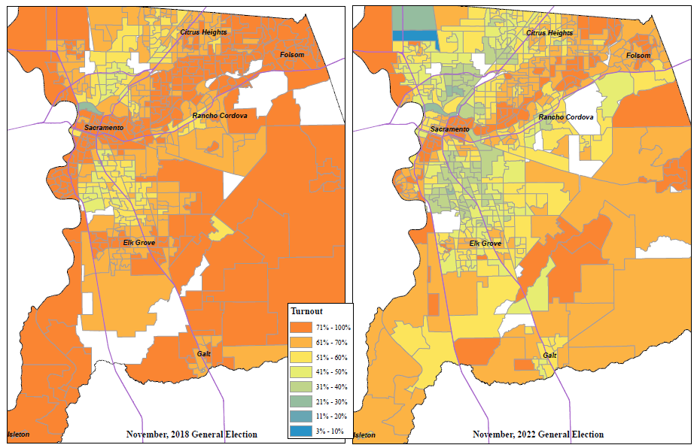
In order to address this identified gap in voter participation, VRE is committed to:
- Recruiting and surveying potential locations in communities that can host an accessible Vote Center.
- Meet with the agencies that provide services to the community, including Women’s Empowerment, Francis House, Maryhouse, Loaves & Fishes, and Salvation Army to provide voter information, voter registration forms, and flyers/posters for the 2024 elections.
- Conducting a registration drive prior to each election at Loaves & Fishes.
- Attending community events that have low voter turnout to provide voter registration and voter education opportunities.
Additionally, VRE has identified areas in the County of Sacramento where voter participation turnout was below the average for the County. These precincts were grouped into zip codes to help with advertising and outreach in specific communities. The list of zip codes below will be used by VRE and our Communication & Media Officer to increase the level of digital advertising in specific areas, as well as other community hubs to help advertise and disseminate election information.

Voter Turnout by Zip Code, November 2022
Zip Code | Voters | Cast Estimate | Turnout
95837 | 138 | 111 | 80.4%
95819 | 12,937 | 9,853 | 76.2%
95683 | 5,327 | 3,977 | 74.7%
95693 | 5,202 | 3,697 | 71.1%
95864 | 17,251 | 12,218 | 70.8%
95818 | 15,212 | 10,757 | 70.7%
95680 | 41 | 29 | 69.7%
95628 | 29,823 | 20,510 | 68.8%
95816 | 12,031 | 8,230 | 68.4%
95630 | 49,146 | 33,222 | 67.6%
95662 | 21,623 | 14,355 | 66.4%
95831 | 28,070 | 18,628 | 66.4%
95639 | 132 | 87 | 66.1%
95690 | 974 | 643 | 66.0%
95608 | 38,750 | 25,470 | 65.7%
95638 | 1,496 | 978 | 65.4%
95615 | 396 | 259 | 65.3%
95641 | 1,158 | 705 | 60.9%
95821 | 19,083 | 11,316 | 59.3%
95814 | 5,353 | 3,150 | 58.8%
95817 | 8,295 | 4,874 | 58.8%
95830 | 611 | 358 | 58.6%
95621 | 25,178 | 14,735 | 58.5%
95670 | 31,232 | 18,182 | 58.2%
95655 | 2,700 | 1,564 | 57.9%
95626 | 3,114 | 1,790 | 57.5%
95610 | 25,649 | 14,739 | 57.5%
95826 | 22,724 | 12,998 | 57.2%
95742 | 10,768 | 6,080 | 56.5%
95678 | 26 | 15 | 56.0%
95632 | 17,275 | 9,655 | 55.9%
95835 | 24,894 | 13,832 | 55.6%
95758 | 38,318 | 21,246 | 55.4%
95624 | 41,563 | 22,995 | 55.3%
95811 | 5,135 | 2,804 | 54.6%
94571 | 116 | 63 | 54.5%
95822 | 24,269 | 13,114 | 54.0%
95825 | 15,634 | 8,363 | 53.5%
95757 | 31,763 | 16,681 | 52.5%
95820 | 18,636 | 9,762 | 52.4%
95827 | 11,388 | 5,917 | 52.0%
95829 | 19,130 | 9,679 | 50.6%
95673 | 8,452 | 4,226 | 50.0%
95843 | 25,863 | 12,907 | 49.9%
95841 | 10,186 | 5,046 | 49.5%
95833 | 21,256 | 10,502 | 49.4%
95834 | 18,765 | 9,022 | 48.1%
95842 | 15,646 | 7,304 | 46.7%
95660 | 14,510 | 6,142 | 42.3%
95828 | 29,422 | 12,242 | 41.6%
95823 | 33,845 | 13,216 | 39.0%
95815 | 10,842 | 4,141 | 38.2%
95824 | 10,946 | 4,072 | 37.2%
95838 | 17,318 | 6,074 | 35.1%
95832 | 4,933 | 1,700 | 34.5%
95652 | 266 | 83 | 31.2%
95640 | 3 | 1 | 21.5%

PART II:

Overview of Election Security Action Plan
§4005(a)(10)(l)(vi)(VIII)(ia), §4005(a)(10)(l)(vi)(VIII)(ib)
All Vote Centers adhere to stringent security standards set forth in Division 19 of the California Elections Code, the California Code of Regulations for Voting Systems, Voting System Use Procedures, and the California Voting System Standards. This includes, but is not limited to, ensuring all equipment at the Vote Center is sealed, stored, delivered, and used in compliance with these regulations. In addition, our current procedures require the majority of the election workers be present when the Vote Center is open.

Security and Contingency Plan to Ensure Prevention of Disruption
§4005(a)(10)(l)(vi)(VIII)(ia)
VRE collaborates through partnerships, internal controls, and procedures to ensure a multi-pronged approach to prevent and mitigate disruption to election operations and processes.

State, Federal, Local Partnerships
We partner closely with the County of Sacramento Department of Technology (DTech), the County of Sacramento Office of Emergency Services (OES), the County Sheriff, and other local law enforcement agencies. We also have direct partnerships with the California Secretary of State (SOS), the Department of Homeland Security (DHS), and Federal Bureau of Investigation (FBI), and the Election Assistance Commission (EAC).
There is increased collaboration before and after an election, in which we enhance our security awareness and communication.

Internal Controls
Mobile Device Management (MDM) allows total control of securing and enforcing policies to smartphones and other devices deployed to a Vote Center. MDM allows the ability to remotely wipe a device, use password enforcement, use data encryption enforcement, and control application distribution and software updates. Voting system components are stored within a secured cage under video surveillance until deployed for the election. All voting equipment is sealed with tamper evident seals, entered into asset management software, and tracked when deployed and returned to VRE.

Vote Center Continuity of Operations
§4005(a)(10)(l)(vi)(VIII)(ib)
Under California voting system requirements, all certified equipment must run on battery power in the event of a power outage. All Vote Center locations are provided with a smartphone for notification in the event of an emergency.
First Responders will receive a list of all Vote Center locations. Each Vote Center will be provided with emergency procedures and be provided with an instruction manual for the contingent operation of a Vote Center and continuity of processing voters.

Vote Center Response During the Voting Period
If any equipment is stolen or appears to have been tampered with at the Vote Centers, replacement equipment will be deployed. Stolen equipment would be a financial loss to the County of Sacramento but would not jeopardize the integrity of the election. Voter information is not stored on any check-in laptops. Additionally, multi-factor authentication is required to make any changes to the accessible ballot marking device or the mobile ballot printer.
During the voting period, trained election support teams from DTech are located throughout the County of Sacramento, ready to respond to any incident. These election support teams have replacement equipment and are trained to resolve technical issues.
All Vote Center equipment functions independently and is implemented with the ability to operate without connection to the internet. Each piece of voting equipment does not directly communicate with any other voting equipment, and if one piece of voting equipment stops functioning, all the other voting equipment will continue to operate.

Incident Response Plan
§4005(a)(10)(l)(iv)
VRE has an in-depth Incident Response Plan (IRP) that will be used in the event of a cybersecurity incident, outage, or attack. The plan provides a systematic way to identify, address, and recover from an incident.
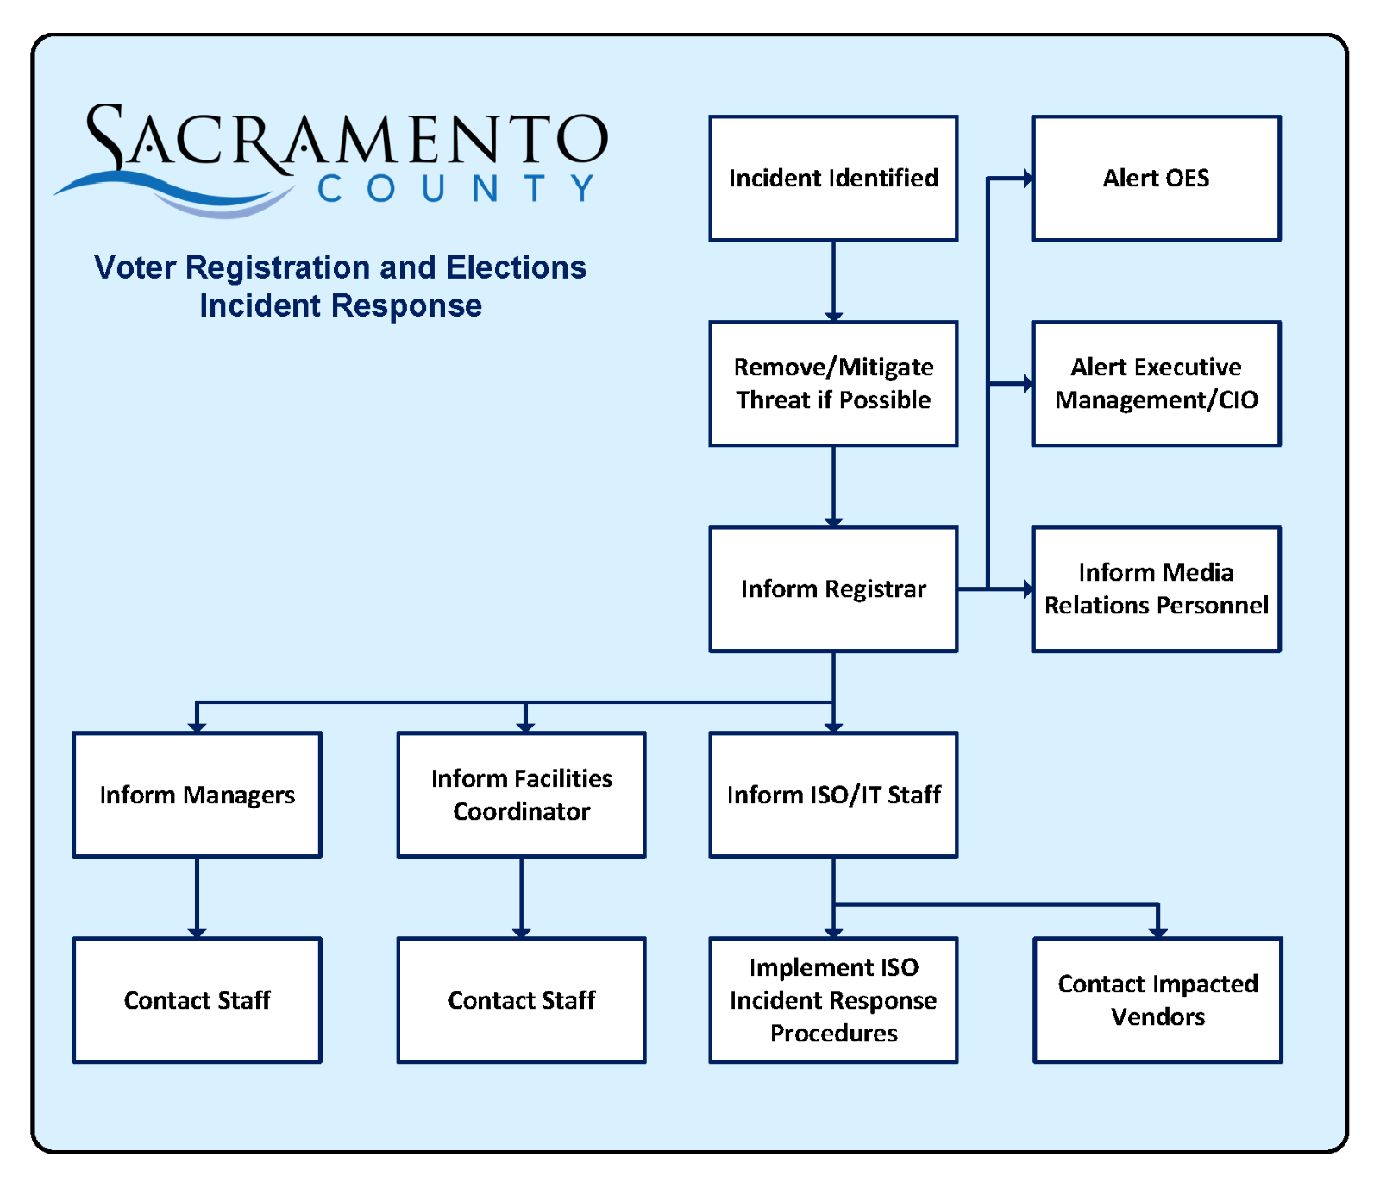

Methods and Standards
The purpose of the IRP is to allow elections operations to continue in the event of a disaster, an incident, or disruption. By identifying the procedures for critical processes, communications, and alternate facilities, most foreseeable disruptions can be mitigated.

Critical Processes
The plan identifies all critical processes required to run an election. Each of these critical processes is analyzed. For each critical process, a recovery strategy is defined, including the restoration of service and steps required for recovery. As an example, providing Vote Center support is one of the many critical election processes identified. To provide support to Vote Centers, staff require access to the database with Vote Center information and contact information. Therefore, the IRP requires that there a contingency for secure connectivity to that database, and a strategy in place to restore the connectivity in a reasonable amount of time in the event a disruption occurs.

Communications
The IRP addresses modes of communication, and how communication can continue during a disruption. This includes alternate modes of communication in the case that primary systems fail. Responsibilities are assigned for disseminating information, and key stakeholders with whom it will be required to communicate in the event of a disruption. The process that is disrupted determines with whom the communication needs to occur. For example, some disruptions will require communication to only Vote Center staff, while other disruptions may require communication to the media and general public.

Alternate Facilities
Alternate facilities are designated for local disasters, such as fires, floods, or other situations that would not allow access to our main facilities.

PART III:

Overview of Voter Education and Outreach Plan
§4005(a)(10)(l)(i), §4005(a)(10)(l)(i)(VI)

Background
The VCA requires the County to develop a Voter Education and Outreach Plan that provides transparency and informs voters on all aspects of the VCA. This includes the services and information available at Vote Center and Ballot Drop Box locations, and information specific to voters with disabilities and language minority voters.
Public meetings will be held with community organizations and individuals that advocate on behalf of, or provide services to, the disability and language minority communities. VRE will hold multiple public education workshops in conjunction with planned community events. All public events hosted by the County will be Americans with Disabilities Act (ADA) accessible.

Summary of Goals
- Voter Engagement and Community Partners
- Voter Education and Student Engagement
- Community Partnerships
- Direct Voter Contact
- Advisory Committees
- Public Service Announcements

Voter Engagement and Community Partners
§4005(a)(10)(l)(i)(III)
Successfully maintaining a community outreach program includes maintaining established partnerships with community-based groups and organizations. VRE regularly meets with dedicated individuals from various organizations across the County of Sacramento including advocacy groups, civic groups, citizen leagues, senior centers, churches, city clerks, political parties, and other individuals.
VRE has provided information about the Vote Center model to many community partners to assist in voter outreach. VRE is attending community events, making presentations to organizations, and training interested individuals and groups to assist with education and outreach.
Community partners and the general public may assist in various ways such as:
- Sharing accurate, non-partisan election information on social media
- Posting election information and links to the VRE website, in a community newsletter or website
- Placing flyers and handouts in offices or locations the public may frequent
- Assist in distributing information, materials, and brochures, including the election specific messaging points
- Participating in community outreach events. An updated list of outreach events is located on our website
- Participating in advisory meetings on messaging, concerns, or common questions from the public
An online toolkit is available for download on the VRE website. This toolkit includes videos, graphics, flyers, brochures, and a VCA presentation. Printed materials may be provided to a group or organization free of charge. Please contact voter-outreach@saccounty.gov for more details.
A list of community events and partners may be found in Appendix A.

Voter Education Workshops for Language Communities
§4005(a)(10)(l)(i)(VI)(ia)
As part of its outreach efforts, VRE will continue its outreach to language minority voters. VRE will work with LAAC members and community partners to provide voters with language assistance at educational workshops. Workshops will be scheduled prior to every statewide election cycle. Locations are to be determined and will be combined with an existing community event. Advertising of these workshops will be done on social media, including Next Door, and through trusted community partners. At these workshops VRE will provide:
- Bilingual* Voter Registration forms
- Language Preference Update forms
- Examples of ballot translation guides with voter instructions, also known as reference ballots
- Translated VCA materials in all state and federally required languages for Sacramento County
*Bilingual registration forms are not provided by the Secretary of State in Punjabi or Hmong. The State of California only provides registration forms in English, Spanish, Chinese, Vietnamese, Hindi, Japanese, Khmer, Korean, Tagalog, and Thai.

Methods to Identify Language Communities
§4005(a)(10)(l)(i)(V)
VRE utilizes self-reported language data recorded on voter registration forms. Voters may also notify VRE of their language preference by telephone, fax, email, or online to update their language preference. Sources such as the United States Census Bureau assist VRE in identifying areas where there may be communities that have limited-English proficiency and may need language assistance.
In addition, VRE receives input from language community partners on the geographic distribution of where language communities exist in the County of Sacramento.

Voter Education Workshops for Disability Community
§4005(a)(10)(l)(i)(VI)(ib)
VRE is committed to working with voters with disabilities to increase accessibility in the democratic process. The VRE website provides general information about these efforts and the resources available to voters with disabilities, including the RAVBM system, disability services available at Vote Centers, availability of election materials in alternate formats, and the VAAC. A full listing of accessible voting options and assistance is located on the VRE website.
Workshops will be scheduled prior to every statewide election cycle. Locations are to be determined and will be combined with an existing community event. Advertising of these workshops will be done on social media, including Next Door, and through trusted community partners. At these workshops VRE will provide:
- RAVBM Information
- Availability of materials in alternate formats (large print, ballot measures on audio, accessible CVIG, and availability of alternate formats for state election materials)

Remote Accessible Vote by Mail Outreach
§4005(a)(10)(l)(i)(II)
VRE established a list of media partners to inform voters on the availability of RAVBM. Messaging and outreach include how to:
- Access the RAVBM system through the Voter Look-Up Tool
- Inform voters of the availability of a VBM ballot in accessible format
The list of media partners may be found in Appendix C.

Care Homes, Hospitals, and Mental Health Facilities
VRE has established a toolkit titled “Helping Your Patient Vote: Guidance for Clinicians and Coordinators” that provides the information necessary for caregivers to assist their patients with checking their registration or registering to vote; acquiring, marking, and returning their ballots; and other tips for encouraging and supporting voter participation in a clinical or long-term care setting.
Additionally, VRE publicly notices the "Helping Your Patient Vote” toolkit through community partners, media partners, the VRE website, and election materials to ensure all voters and members of the public within the County of Sacramento are aware that voters in care facilities and hospitals can authorize a coordinator to retrieve and return ballots on their behalf.

High Schools and Higher Learning
VRE conducts extensive outreach to local high schools through programs, such as High School Mock Elections, to provide materials to educate students about the election process; and voter registration drives to register and pre-register eligible students.
VRE will continue to partner with local colleges throughout the County to provide information and resources about the election process, the Vote Center model, and upcoming elections through presentations, campus events, and registration drives. Currently, VRE meets regularly with California State University Sacramento to ensure students understand their voting options and what services will be available at the Vote Center on campus for both elections in 2024.

County Detention Facilities, Probation, and Parole
VRE has established relationships with county detention facilities, and the Probation department to provide voter registration training, election information, news stories, flyers and posters, updates, and we remain available to answer questions as they assist voters throughout the year.
As a part of our partnership, VRE regularly:
- Coordinates the receipt of voter registration forms
- Distributes Official Ballots for each facility
- Facilitates Conditional Voter Registration
VRE also provides volunteer training to outside organizations that have arranged with the Sheriff’s department to register individuals at the county detention facilities.
We will continue to work with community organizations and advocates to identify how we can support efforts to inform those on probation or on parole of their rights to register and vote.

General Media Plan
§4005(a)(10)(l)(i)(I)
To inform the voters in the County of Sacramento of the upcoming elections, VRE will take an expansive approach to reach as many voters as possible, multiple times. Advertising tactics include, but are not limited to, social media, direct mailing, print, broadcast, video, digital, outdoor signage, audio, and radio. VRE’s goal is to saturate the spectrum of media outlets for voters to increase the potential for a voter to see informational and marketing materials.
In addition to reaching the general market, the media campaign will feature in-language ads targeting hard to reach communities, low voter turnout areas, underserved populations, and more.

Community Action Plan
Based on community feedback and input, VRE has established the following messaging points that will be prevalent in all outreach and education materials:
March 5, 2024 Presidential Primary Election:
- Vote early to avoid the lines
- Postage is paid on VBM ballot return envelopes
- The 2024 Presidential Primary Election is in March
- Check your registration status; the Primary Election is party specific
- The CVIG is monolingual, update your language preference
These five points will be disseminated through social media, partners, in our communication with the public, and on our flyers and informational handouts. VRE will continue consistent efforts to ensure that the public is aware of how to register to vote and participate in upcoming elections, and services available at Ballot Drop Box and Vote Center locations.
November 5, 2024, Presidential General Election:
- Vote early to avoid the lines
Additional messaging will be determined by VRE after review of March Primary Election voter questions and calls, community meetings, and Vote Center Experience Survey results.

Direct Voter Contacts
§4005(a)(10)(l)(i)(X)
Since the 2018 election cycle, direct contact from VRE to voters was a method used to inform voters about the changes under the VCA. VRE will mail two direct postcards to each registered Sacramento County voter. The general purpose of these direct contact postcards is to provide information on the upcoming election, the availability of VRE’s toll-free voter assistance hotline, and voting options.
- First Postcard: The first mailing will be sent approximately 120 days before each election, reminding voters to watch for their VBM ballot and to check their status to make sure they are registered correctly for the upcoming party specific primary in March.
- Second Postcard: The second mailing will be sent approximately 22 days before the election to remind voters when Vote Centers open, options for returning their ballot, including reminder to sign their envelope between the hole punches, and to vote early and avoid lines on Election Day.
All registered voters will receive an English postcard. If a registered voter has a Spanish, Chinese, or Vietnamese language preference listed on their voter file, they will receive an additional postcard in that language.
Sample postcards from 2022 are included in Appendix B.

Media Partners
§4005(a)(10)(l)(i)(II), §4005(a)(10)(l)(i)(VIII)
VRE works in partnership with community organizations, government agencies, school districts, and other groups to raise awareness of the Vote Center model. This will be combined with a broad media campaign using direct mailings, news media, radio, social media, public access media, and public service announcements (PSA). The campaign will promote the toll-free voter assistance hotline, inform voters with disabilities how to obtain their ballot in an accessible format, and provide multilingual services to language minority voters.
VRE will partner with community organizations to attend community events and provide education and outreach opportunities to voters.
A general timeline for VRE’s Communication Action Plan can be found in Appendix F.

Language Media Partners
§4005(a)(10)(l)(i)(l)
Press releases distributed throughout Sacramento County will announce the toll-free voter assistance hotline. The toll-free voter assistance hotline provides aid in English, Spanish, Chinese, and Vietnamese with the ability to connect with live interpretation services that can provide access to over 200 languages and dialects. Additionally, media advertisements in Spanish, Chinese, Vietnamese, Hmong, Korean, Punjabi, Tagalog, Hindi, Japanese, Laotian, Mien, Telugu, and Urdu will be purchased to promote the toll-free voter assistance hotline, as available within the County.
Media partners, including multilingual media, are included in Appendix C.

Disability Community Media Partners
§4005(a)(10)(l)(i)(l)
Press releases distributed throughout Sacramento County will announce the toll-free voter assistance hotline which will connect voters with disabilities with TTY (Text Telephone), allowing voters who are deaf, hard of hearing, or speech-impaired to use the telephone to communicate with VRE staff. Future press releases will state that the voter assistance hotline has TTY abilities.
For additional information regarding the toll-free voter assistance hotline, see page 16 of this document.
Printed materials, such as the second direct postcard and the “I Voted” Sticker insert in the VBM ballot packet advises voters of accessible ballot options.
Media partners are included in Appendix C.

Postage-Paid Postcard for Requesting Materials in an Alternate Language or an Accessible Format
§4005(a)(8)(B)(iii)
All registered voters will receive a postage-paid postcard in their CVIG to request a VBM ballot in an accessible format and to request election materials in alternate languages per Election Code §14201 and the Voting Rights Act Section 203. Instructions will be included in the CVIG and on the VRE website for completing and returning the postcard.

Public Service Announcements
§4005(a)(10)(l)(i)(VIII), §4005(a)(10)(l)(i)(IX)
VRE will use PSAs in visual and audio formats to inform voters of the upcoming election and the toll-free voter assistance hotline. The PSAs will be distributed through television, radio, newspapers, social media, and the County’s electronic billboard in order to reach all voters, including voters with disabilities and language minority voters. The LAAC and VAAC will assist in developing and ensuring accessibility of PSA content.
The PSAs will be provided to the outlets listed in Appendix C.
A general timeline for PSAs and contact with other media outlets is located in Appendix F.

Individual Voter Network
Outreach and education activities are not limited to organizations. Individual voters may serve as part of a support network to alert VRE to barriers to voting and provide solutions to ensure widespread awareness of the Vote Center model. VRE provides Voter Experience Survey cards at Vote Centers to receive comments about voters’ experiences. Survey questions include access to the Vote Center and use of language services among other questions. VRE utilizes an electronic call log to track all incoming calls which can help improve messaging and address recurring questions or concerns.

Website
§4005(a)(10)(l)(i)(IV)
VRE’s website, elections.saccounty.gov will be utilized heavily as the main source of Vote Center information and election material for the public. Information on the website will be provided in accessible formats. This will include the EAP, methods to request an accessible mail ballot, how to use an accessible ballot marking device, lists of Vote Centers and Ballot Drop Box locations, and other pertinent information related to the VCA.
Beginning 29 days before Election Day, VRE’s website will be updated with the following information:
- Voter Look-up Tool, which allows any Sacramento County voter to:
  - Verify their voter registration information
  - Verify their voted ballot has been received by Sacramento County
  - Find the nearest Vote Center or Ballot Drop Box location to their residence
  - View their CVIG
  - Access the RAVBM system
- Vote Center and Ballot Drop Box locations
- Ballot measure information in audio for Sacramento County
- Election Results, in HTML and interactive formats
- Resource toolkit for voter education materials and publications
- Information on Accessible Voting Options, including information on what is available at a Vote Center, curbside voting, RAVBM, and materials in accessible formats.
Materials on the website are also translated in languages so voters with limited-English proficiency may access important election information.

Projected Budget for Voter Education and Outreach
§4005(a)(10)(l)(i)(VII), §4005(a)(10)(l)(v)
The VCA requires extensive voter education and outreach about the Vote Center model voting process. VRE’s goal is to increase voter registration, participation, and turnout.
VRE provides in-house support for the preparation of outreach materials, public presentations, and community outreach events. The budget includes the purchase of advertisements in television, radio, newspapers, and social media, as well as printing and postage costs for direct mailings to registered voters.
The budget information for education and outreach can be found in Appendix D. If additional money is provided for voter education and outreach efforts, the Appendix will be updated to reflect any changes or additions.

